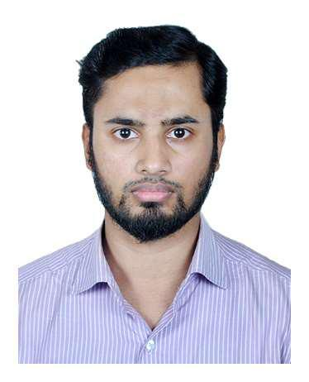MOHAMMAD SUBBIR JAHAN CHOWDHURY

Roisa Bhaban(2nd Floor), House No-306, Sabujbag, Halishohor, Chittagong. 01794-555249 [jahansubbir@gmail.com](mailto:jahansubbir@gmail.com) <https://www.linkedin.com/in/mohammad-subbir-jahan-chowdhury-301b09112/>

**Objective**

Possessing a stable platform with a satisfactory working environment that enables to exploit my problem solving skill set, and lets me to carry on a continuous learning process and provide a pathway to advancement.

**Employment History**

* **Programmer(.net) (February 01, 17 - continuing)**

Asian Technologies Ltd.

Nessa Bhaban (3rd floor), 969, Nasirabad, CDA Avenue, Chittagong.

Responsibilities:

1. Design, code, test and implement database and software as per the requirements and direction from the leader.
2. Take part in R&D.
3. Maintain windows server, MSSQL server.
4. Look up network issues.
5. Provide software support

**Projects**

* **ATL Conveyance Bill Management**

A web application that enables employees to submit their work log and conveyance bills; the management body keeps track of those for checking and for future use.

Building material: C#, MVC, MSSQL, Jquery, AJAX, Crystal Report

<http://103.214.201.59/atlinvoice>

Github:<https://github.com/jahansubbir/atlinvoice.git>

* **mango-inventory**

Inventory management software that allows user to save product information, do quotation, challan, product stock, ledger etc.

Building material: C#, Entity Framework, Crystal Report

<http://103.214.201.59/mango-inventory> (testing).

**Skills**

C#, ASP.Net (MVC, Entity framework, Web API), Java, MS SQL Server 2008/2012, MySQL, Crystal Report, JavaScript, AJAX, Jquery, Computer Networking (CCNA), Arduino, Basic Linux, Bash Scripting, LAMP configuration.

**Educational Qualification**

* B.Sc(Engineering)

Applied Physics, Electronics & Communication Engineering

University of Chittagong

CGPA 3.39 out of 4

Passing Year 2014

* Higher Secondary Certificate

Science

Government City College, Chittagong

GPA 4.40 out of 5

Passing Year 2009

* Secondary School Certificate

Science

Government City College, Chittagong

GPA 5 out of 5

Passing Year 2007

**Training**

* Web App Development- Dot Net

Topics- Basic C#, OOP basics, Web basics(HTML, CSS, JavaScript), Working with database: MS SQL Server, Web Programming using ASP.Net web form, Web Programming using ASP.Net MVC, Software Project Management & project work.

Institute- BASIS Institute of Technology & Management (BITM)

**Academic Project**

* An Approach To Find The Estimated Time Of Arrival(ETA) Of A Remote Vehicle Using Global Positioning System(GPS).

**Language Proficiency**

English: Fluent in both written and verbal form.

**Personal Details**

Father's Name: Mohammad Shah Jahan Chowdhury

Mother's Name: Samsujahan Chowdhury

Date of Birth: February 7, 1992

Marital Status: Single.

**References**

* Saumitra Kumar Kuri

Assistant Professor

Department of Applied Physics, Electronics & Communication Engineering

University of Chittagong

Phone: 0312606001-10

Cell: 01715653265

Email: skkuri@cu.ac.bd

* Ahsan Hamidullah Chowdhury

Principal Officer & Manager- Operation Southeast Bank Ltd.

Kandir par Branch, Comilla.

Phone: 031-64279

Cell: 01816155022